Abstract Submission for Maltese Cardiac Society Conference 2016

Title: Transthoracic Echocardiogram Requests for Suspected Infective Endocarditis: A Local Perspective

Corresponding author: Trevor Tabone (561591M)
Email: trevor.tabone@gov.mt
Mobile: 79689325/79003519

Co-authors: Daniele Lauretta Agius; Francesca Spiteri; Daniela Cassar Demarco; Robert G Xuereb; Tonio Piscopo

Background

Infective endocarditis (IE) is a diagnostically challenging, potentially fatal condition. Transthoracic echocardiography (TTE) is the recommended first-line imaging modality despite its relatively low sensitivity. This audit aims to gain a clinical and microbiological perspective into TTE requests for suspected IE in Mater Dei Hospital and to determine the local sensitivity and NPV (Negative Predictive Value) of initial TTE in suspected IE.

Method
Urgent TTEs for suspected IE requested between May & December 2015 were selected (127 patients). TTE and TOE (trans-oesophageal echocardiogram) reports were obtained from Xcelera, whilst iSoft Clinical Manager and Electronic Case Summary used to gather further data.

Standards Used

American Heart Association and European Society of Cardiology guidelines were used.

Results

Patients were classified according to TTE results into 3 categories: Negative (60.6%), Positive (5.5%) & Equivocal (33.9%) TTE. The NPV of negative and equivocal TTE was 85.7% and 78.6% respectively. TTE sensitivity was 55% - comparable to Barton et al. 93% of patients had blood cultures taken. 48.3% were bacteraemic, 43.9% of which had Staphylococcus aureus.

Discussion

TTE has its limitations and pitfalls and must be interpreted within the clinical context, given its low sensitivity rates. However, in patients with a low clinical suspicion of IE and negative TTE, IE may be excluded. Those with equivocal TTE and high clinical suspicion of IE, will benefit from TOE.

Key messages for recommendations

- Duke’s Criteria should be used to stratify patients into ‘Definite’, ‘Possible’, or ‘Rejected’ IE
- Negative TTE and a low clinical suspicion for IE warrants consideration of an alternate diagnosis.
- Encouraging use of algorithms:

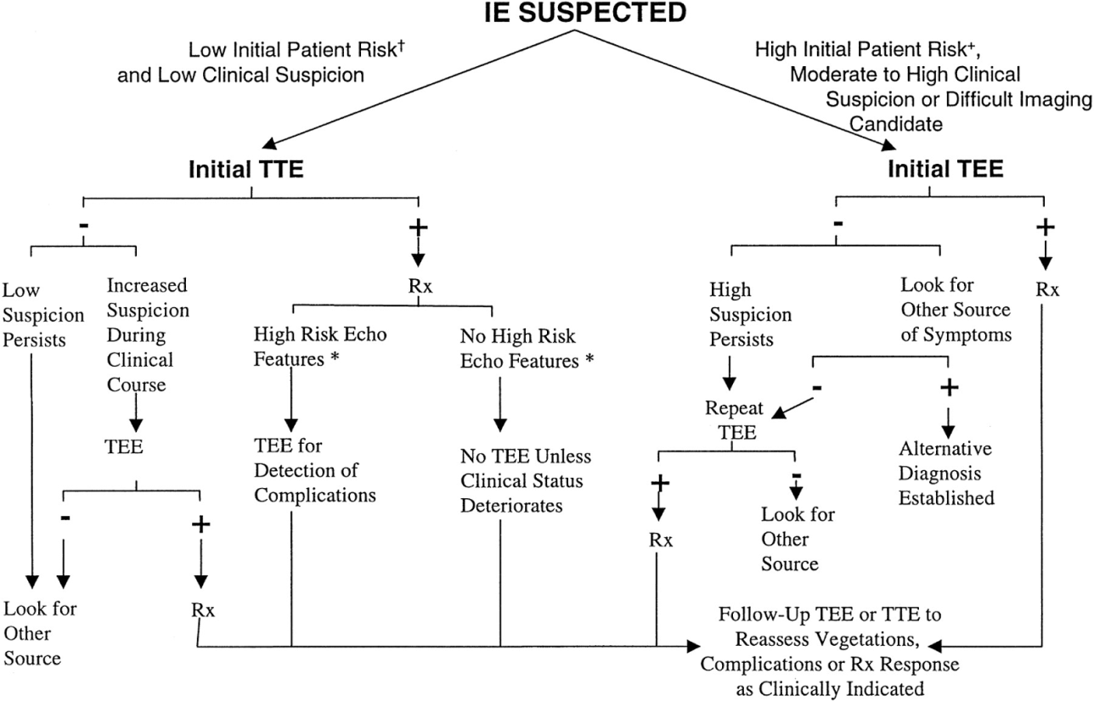

Figure: An approach to the diagnostic use of echocardiography (Reproduced from Bayer et al.)

References

Baddour LM. Infective Endocarditis: Diagnosis, Antimicrobial Therapy, and Management of Complications: A Statement for Healthcare Professionals From the Committee on Rheumatic Fever, Endocarditis, and Kawasaki Disease, Council on Cardiovascular Disease in the Young, and the Councils on Clinical Cardiology, Stroke, and Cardiovascular Surgery and Anesthesia, American Heart Association: Endorsed by the Infectious Diseases Society of America. Circulation. 2005Jun;111(23).
Barton TL, Mottram PM, Stuart RL, Cameron JD, Moir S. Transthoracic Echocardiography Is Still Useful in the Initial Evaluation of Patients With Suspected Infective Endocarditis: Evaluation of a Large Cohort at a Tertiary Referral Center. Mayo Clinic Proceedings. 2014;89(6):799–805.
Bayer, Arnold S et al. "Diagnosis and management of infective endocarditis and its complications." Circulation 98.25 (1998): 2936-2948.
Cecchi, Enrico et al. "The diagnostic utility of transthoracic echocardiography for the diagnosis of infective endocarditis in the real world of the Italian Registry on Infective Endocarditis." Echocardiography 30.8 (2013): 871-879.
European Heart Journal [Internet]. 2015 ESC Guidelines for the management of infective endocarditis. [cited 2016Feb28]. Retrieved from: http://eurheartj.oxfordjournals.org/content/early/2015/08/28/eurheartj.ehv319
Greaves, K et al. "Clinical criteria and the appropriate use of transthoracic echocardiography for the exclusion of infective endocarditis." Heart 89.3 (2003): 273-275.
Habib G, Badano L, Tribouilloy C, Vilacosta I, Zamorano JL, Galderisi M, et al. Recommendations for the practice of echocardiography in infective endocarditis. European Journal of Echocardiography. 2010Jan;11(2):202–19.
Sivak JA, Vora AN, Navar AM, Schulte PJ, Crowley AL, Kisslo J, et al. An Approach to Improve the Negative Predictive Value and Clinical Utility of Transthoracic Echocardiography in Suspected Native Valve Infective Endocarditis. Journal of the American Society of Echocardiography. 2016;
Thuny, Franck et al. "Imaging investigations in infective endocarditis: current approach and perspectives." Archives of cardiovascular diseases 106.1 (2013): 52-62.

